**Assembly instructions document**

This document serves as the assembly instructions for a three channel input (10X) probe adapter board for the Raspberry Pi Pico module. The adapter board scales the 0 to 3.3 V input range of the Pi Pico module by 10X and provides a means to offset the range to provide negative input voltages. An input range of +/- 16 V at the pin marked DC is the nominal configuration when the pin connected to the 100kΩ of the input divider is connected to VCM (1.65V). Other input divider configurations are possible. The board also contains two R/2R SIP resistor arrays that provide two 8 bit DAC AWG output channels.

These instructions do not teach the reader how to solder through-hole printed circuit boards. We could reproduce a soldering tutorial here but seriously, there are so many good ones out there already, it's probably a waste of time. If the reader has little experience soldering then the following tutorials from SparkFun may be useful:

https://www.sparkfun.com/tutorials/106

https://learn.sparkfun.com/tutorials/how-to-solder-through-hole-soldering

Other such soldering tutorials may be found on line as well.

The Pi Pico board has castellated mounting holes and the following tutorial may be of help when mounting the Pi Pico:

https://learn.sparkfun.com/tutorials/how-to-solder-castellated-mounting-holes

**Bill of Materials:**

|  |  |  |  |
| --- | --- | --- | --- |
| Item | Qty | Reference(s) | Value |
| 1 | 5 | C1, C2, C3, C4, C7 | 0.22u |
| 2 | 2 | C5, C6 | 1n |
| 3 | 1 | J1 | One 1X16 or Two 1X8 Female Header |
| 4 | 1 | J3 | 1X8 Female Header |
| 5 | 1 | J4 | 1X8 Female Header |
| 6 | 7 | R1, R2, R3, R4, R5, R6, R7 | 510 |
| 7 | 6 | R8, R9, R10, R11, R18, R19 | 10k (CF18JT10K0CT-ND) |
| 8 | 3 | R12, R14, R16 | 100k (CF18JT100KCT-ND) |
| 9 | 3 | R13, R15, R17 | 910k (CF18JT910KCT-ND) |
| 10 | 2 | RDACA1, RDACB1 | R-2R 10k (4610X-R2R-103LF) |
| 11 | 2 | U1, U2 | LM324 or MCP6004 |
| 12 | 1 | U3 | Pi Pico (2648-SC0915CT-ND) |

Amplifiers U1 and U2 use the standard pinout for quad op-amps and any version that can operate from a 4.7 V power supply could potentially be used. Rail-Rail input / output capable amplifiers are best suited for this application. Low cost quad devices such as the LM324 or similar can be used because it supports an input common mode voltage that includes ground. Depending on the particular version / vendor of the LM324, pull down resistors R1, R2, R3, R4, R5, R6, R7 (510 ohm) may or may not be needed. If a true Rail-Rail amplifier such as the MCP6004 is used resistors R1, R2, R3, R4, R5, R6, R7 can be omitted.

It is best to start assembly with the components with the lowest profile, like the resistors. Place all the resistors of the same value at a time and solder them in place before moving on to the next value. Locate where each resistor goes by the reference designator (R1, R2 etc.) on the silk screen (Note: figure 2.) A small piece of masking tape can be used to hold the resistors tight to the top surface of the board while soldering the leads on the bottom of the board. Once all the resistors are installed move on to the next highest profile components like the DIP op-amp. Be sure to note the notch in the silk screen outline for the op-amp and Pin 1 designated by the square solder pad. Be sure to insert the op-amp properly aligned with Pin 1.

The Pi Pico board can be installed directly on the SMD pads using the U3 location with the USB connector facing outward toward the PCB board edge (Note: figure 3 assembled PCB).

The female header sockets are the tallest and should be installed last.

**Schematic and board layout for 4/26/2024 Prototype:**

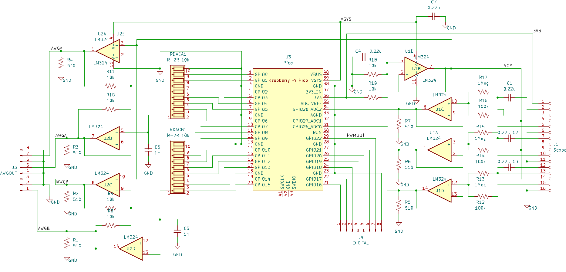

Figure 1 Raspberry Pi Pico 10X probe schematic (prototype)

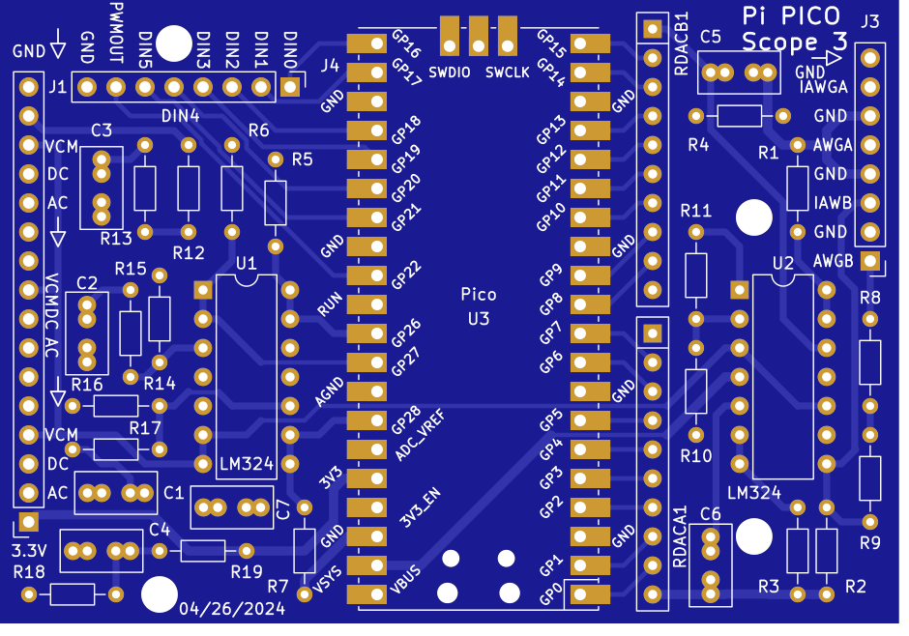

Figure 2 Raspberry Pi Pico 10X probe PCB Top - silk screen (prototype)

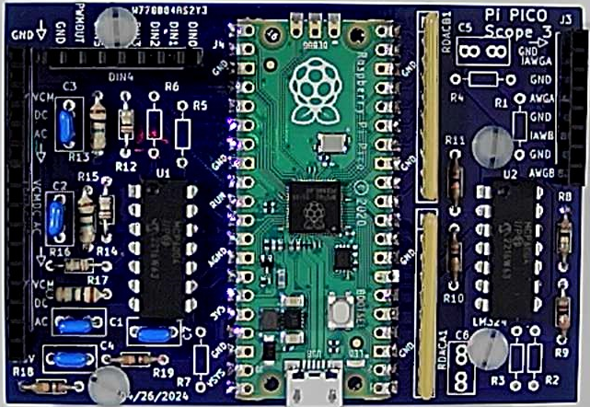

Figure 3 Raspberry Pi Pico 10X probe PCB (prototype) assembled (MCP6004).

**Resistor Color Code:**

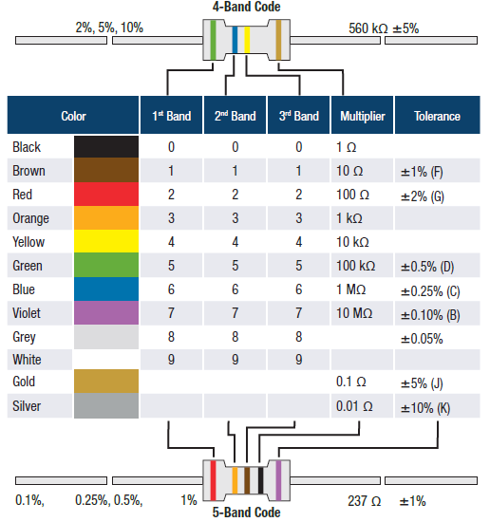

**Soldering Hints:**

1. Insert the component tight against the PCB surface and carefully solder the leads.

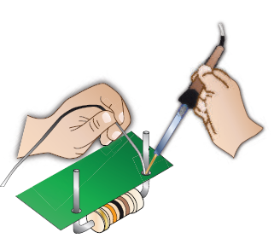

2. Make sure the solder joints completely surround the component lead and are cone-shaped and shiny.

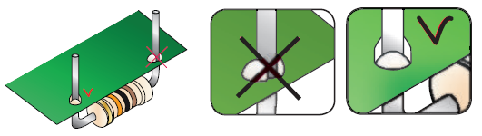

3. Trim excess leads as close as possible to the solder joint.

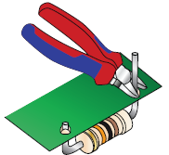

**Appendix for Version 3 Layout (5/11/2024):**

The version 3 design is electrically identical to the prototype. The physical arrangement of the components was changed to make more sense.

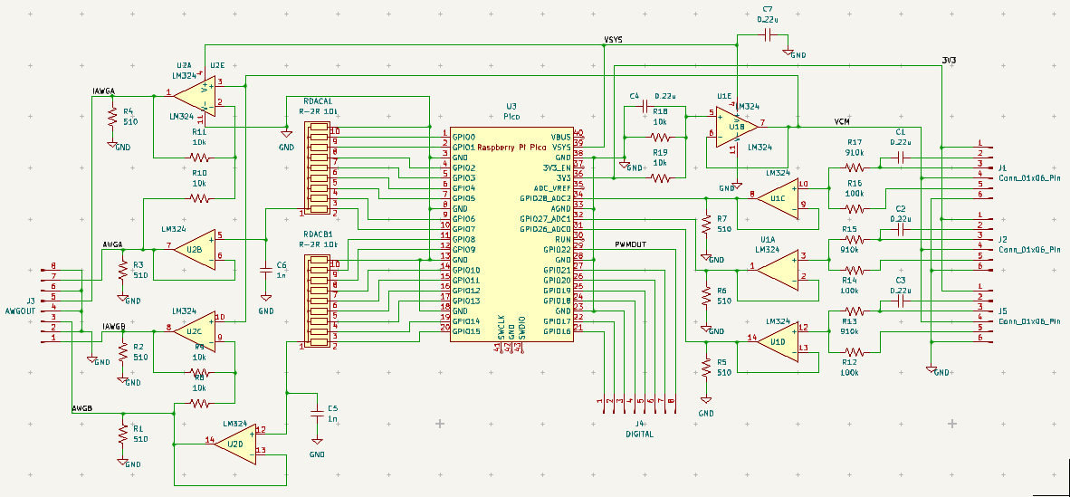

Version 3 schematic

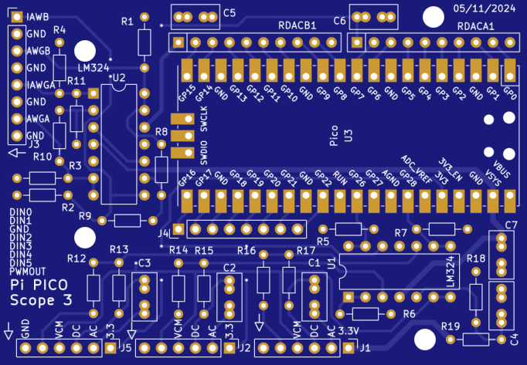

Version 3 Top Silk screen

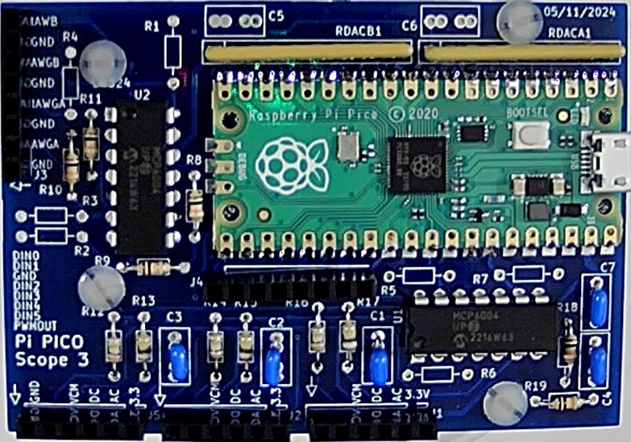

Assembled Version 3